MacOS Support: Installing Fonts
Official URL: https://services.smsu.edu/TDClient/180/Portal/KB/Article/4301/MacOS-Support-Installing-Fonts
Category: Knowledge Base > Information Technology Services > Computer, Device, and Printing Support > MacOS Support: Installing Fonts
Tags: mac, fonts, macOS
_____________________________________________________

Installing Fonts
MacOS users are able to download specific fonts not included in the standard font options. These guidelines provide access to essential branding tools, including fonts and templates often used by the marketing and publications office to maintain consistent visual standards. Student workers and staff frequently rely on these resources, and while many are readily available, specific downloads require the steps outlined below.

Installing Fonts on macOS
Follow these steps to install a font manually on your Mac:
- Open the “Go to Folder” Dialog: Click anywhere on your desktop to bring Finder into focus and in the top menu bar, click "Go" then scroll to "Go to Folder..." and click that as well
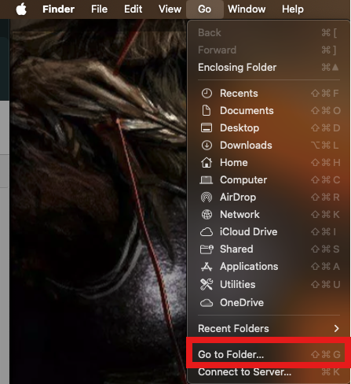
Figure 1: Mac Finder “Go” menu is open showing navigation options such as Recents, Documents, Desktop, Downloads, iCloud Drive, Applications, and Utilities, with the “Go to Folder…” option highlighted at the bottom.
- Navigate to the Fonts Folder: In the dialog box that appears, type the following path: /Users/[StarID]/Library/Fonts. Replace [StarID] with your actual StarID (e.g., ab1234cd) and click Go.
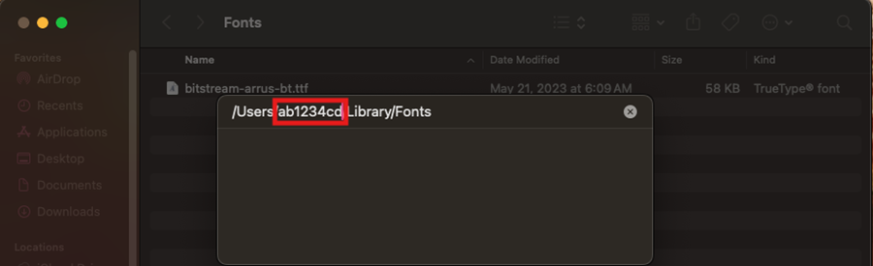
Figure 2: Mac Finder “Go to Folder” dialog box is open over a Fonts folder window, showing a path field with “/Users/ab1234cd/Library/Fonts,” with part of the username highlighted.
- Install the Font: Locate your .ttf font file then drag and drop the .ttf file into the Fonts folder you just opened.
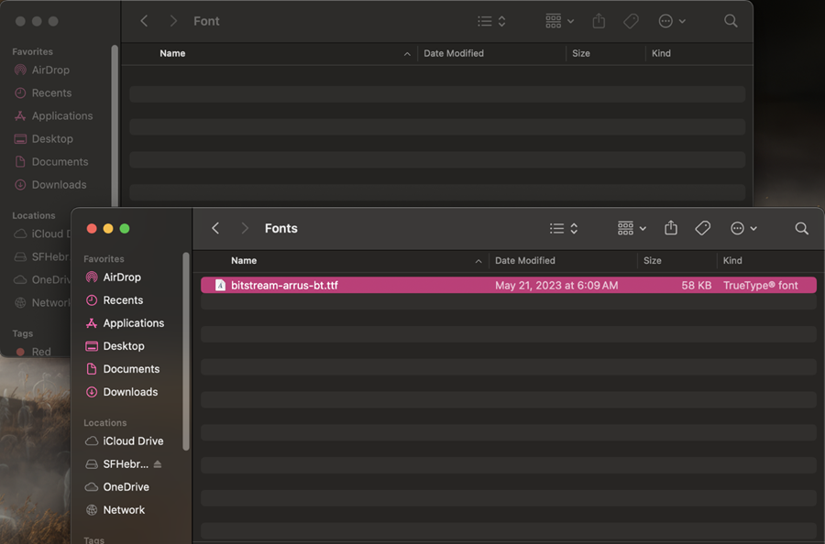
Figure 3: Two overlapping macOS Finder windows are open in dark mode. The front window, titled “Fonts,” shows a single selected file named “bitstream-arrus-bt.ttf,” with details including date modified “May 21, 2023 at 6:09 AM,” size “58 KB,” and type “TrueType® font.” The Finder sidebar on the left displays locations such as AirDrop, Recents, Applications, Desktop, Documents, Downloads, iCloud Drive, and OneDrive. The background window shows another empty “Font” directory.
- Verify Installation: Open an application like TextEdit or Microsoft Word and check the font list to confirm your new font appears and is usable.
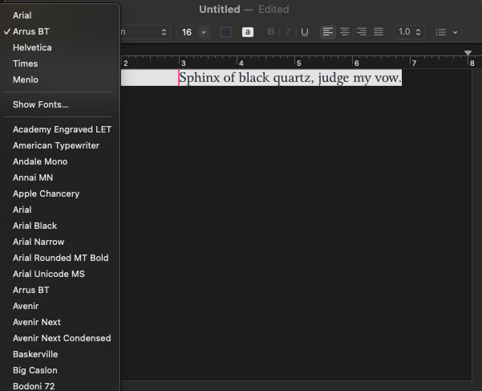
Figure 4: macOS text editing window in dark mode with the font dropdown menu open. The font “Arrus BT” is selected, and a list of other fonts such as Arial, Helvetica, Times, and Menlo appears below. In the document area, the sentence “Sphinx of black quartz, judge my vow.” is highlighted, demonstrating the selected font.
Accessibility Review & Update Log:
- [x] Content accuracy and link integrity verified
- [x] High-contrast visual hierarchy implemented (Inter and Calibri)
- [x] Image alt-text captions verified (all screenshots captioned)
- [x] Outline headers and standard list sequences optimized for screen readers

